

Fire Risk Policy

2023- 2024

|  |
| --- |
|  |
|  |
| Updated: January 2023  Longridge Town Council  Authored by: Town Clerk |

|  |  |
| --- | --- |
| cid:2887E7B4-4235-4453-B7C9-14F4166BF0CB | Longridge Town Council  Council Offices, The Station Building  Berry Lane, Longridge. PR3 3JP  Telephone: **01772 782461**  email: [clerk@longridge-tc.gov.uk](http://h)  website: [www.longridge-tc.gov.uk](http://h) |

**Mission Statement**

Endeavour, through foresight and leadership, to enhance quality of life for Longridge residents and visitors.

Working to enrich facilities and nurture opportunity,

to protect and improve the built and natural environment and promote community pride.

__________________________________________________________________________________________

**Longridge Town Council**

**Fire Policy**

**1. Statement of Intent**

1.1 Longridge Town Council [“LTC”] is a responsible employer and recognises the importance of fire safety in the workplace. Good fire safety practices prevent and reduce the risk of harm to employees, contractors, members of the public and other parties who may be affected by Council operations or activities. LTC has formulated a Fire Policy to comply with the Regulatory Reform (Fire Safety) Order 2005, Health and Safety at Work Act 1974 and other relevant legislation which outlines the responsibilities and duties of all people in the organisation.

**2. The Council**

The Council is responsible for:

(a) Protecting the safety of its employees

(b) Protecting the safety of the general public on Council property or who may be affected by its operations

(c) Protecting the safety of vulnerable people who may be on Council property or who may be affected by its operations

(d) Protecting the safety of contractors and volunteers who may be working for or on behalf of the Town Council on LTC property or other premises

(e) Complying with government legislation on fire safety

(f) Having a comprehensive Fire Policy which is reviewed regularly and revised periodically or following major changes which could alter its effectiveness

(g) Providing sufficient funding to meet legislation and its responsibilities outlines in section 2.1

(h) Providing sufficient staffing, training and resourcing to meet legislation requirements and Council’s responsibilities outlined in section 2.1

**2.2 The Town Clerk is responsible for:**

(a) Monitoring government legislation on fire safety.

(b) Following procedures and adhering to their training.

(c) Taking all reasonable and necessary precautions to keep themselves and others around them safe.

(d) When budget setting, ensuring that sufficient finance is available for fire safety including training, servicing and adjustments needed as a result of fire risk assessments.

(e) Delegating responsibilities to nominated fire marshals to oversee day to day operational fire safety procedures, and safe evacuation procedures in the event of a fire incident.

(f) Establishing correct and safe procedures in line with legislation and organisation requirements and ensuring adherence to the same.

(g) Ensuring there is a comprehensive Health and Safety Policy and separate Fire Policy in place, which is reviewed routinely by the Estates Committee and then ratified by full Council.

(h) Disseminating fire safety information to the Council.

(I) Ensuring there is sufficient firefighting equipment on Council premises, in accordance with fire risk assessment requirements.

(j) Reporting any faults or defects with fire safety equipment, hazards, or concerns they may have around fire policy and safety.

**2.3 Estates Committee are responsible for:**

(a) Ensuring adherence to the Fire Policy and procedures.

(b) Assessing training needs and reporting this back to the Staffing Committee.

(c) Ensuring comprehensive induction training is given to new starters, and adequate supervision provided thereafter, on fire policy and procedures.

(d) Reporting defects and concerns to full Council.

(e) Familiarising themselves with the Fire Policy, fire legislation and organisational procedures.

(f) Ensuring appropriate risk assessments are in place.

**2.4 Nominated Fire Marshals**

1. Miss Jessica Dibble Mon – Fri 9:00 -14:30

**2.4.1 Fire Marshals are responsible (where applicable) for:**

**2.4.2 Day to day housekeeping:**

(a) Ensuring workspaces are kept tidy and free of clutter.

(b) Ensuring bins are emptied routinely and rubbish is not allowed to build up or be stored in inappropriate places.

(c) Ensuring access routes and fire exits are kept clear and unobstructed.

(d) Ensuring appropriate use of extension cables and PAT testing of equipment.

**2.4.3 Monthly:**

(a) Checking that the fire alarm test has been carried out.

(b) Checking that the exit fire doors have been tested for ease of opening.

(c) Checking that the fire extinguisher checks have been completed.

(d) Checking that a fire evacuation drill has been carried out.

(e) Checking that PAT testing in our individual areas has been carried out.

**2.4.4 Six monthly:**

(a) Checking that a fire evacuation drill has been carried out.

**2.4.5 Annually:**

(b) Checking that PAT testing has been carried out.

**3. Fire Risk Assessments**

3.1 Fire Risk Assessments will be carried out by the Lancashire Fire and Rescue Service, or one of their associated improved inspectors. The risk assessment will be reviewed annually by the Estates Committee and revised every three years, or following any major changes on the premises which may include but is not limited to:

(a) The addition of new equipment.

(b) Alterations to the building, both internal and external, including building layout.

(c) A change to or addition of any hazardous substances used or stored on the premises.

(d) Fire equipment failure.

(e) Changes to the occupancy of the building.

(f) Changes to the level of mobility of those occupying the building, or the change or addition of users or visitors who may be vulnerable.

(g) Changes to the lettable area of the premises.

3.2 Recommendations given in the fire risk assessment must be completed within the given timescales, with higher risks given the highest priority to rectify.

3.3 There must be funds available to complete recommendations in the fire risk assessment. It is the responsibility of the Council to provide for this in their annual budget.

**4. Monitoring**

4.1 Monitoring of the policy and adherence to it, effectiveness of training and budget spent will be undertaken by the Staffing Committee, Budget Committee and the Estates Committee, who will report to full Council. The Clerk will be responsible for ensuring that monitoring is part of the agenda.

4.2 The annual review of the policy will be completed by the Estates Committee.

4.3 The Clerk is responsible for overseeing the monitoring of day-to-day adherence to the policy and procedures, and should liaise with Estates Committee to address any concerns.

4.4 Appropriate and realistic timescales must be put in place to address any shortcomings. The appropriate Committee must ensure that any remedial actions are carried out.

4.5 All serious fire safety incidents will be subject to investigation, with a report and findings presented to full Council.

**5. Logbook**

5.1 A log book will be kept on the premises and will contain details (where applicable) of:

(a) Fire alarm model details, testing, servicing, false alarm and evacuation events.

(b) Emergency lighting testing and servicing.

(c) Fire extinguisher inspection and servicing.

(d) Emergency contact details for responsible people and key holders.

(e) Fire maintenance company details and contacts.

(f) Locations of call points, detectors and other fire safety components, which may in the form of a colour coded floor plan. [Appendix A]

**6. Procedures**

**6.1 If you hear the fire alarm**

6.1.1 Calmly evacuate the area without stopping to collect any possessions. Leave via the nearest, safe and unobstructed fire exit. Proceed to the assembly point at that premises (Barclay Street is our nominated fire assembly point). [Appendix B]

6.1.2 If you are unable to exit the building, either because of blocked fire exits or limited mobility, proceed to the refuge point and await assistance. [Appendix C]

6.1.3 Do not re-enter the building until instructed to do so.

**6.2 If you discover a fire**

6.2.1 Find the nearest call point and press the Manual Call Point.

6.2.2 If you are trained to tackle the fire, have the correct equipment to do so and are confident that you can do so safely, you may attempt to. If the fire is too large, or the situation becomes too dangerous for you to remain, evacuate immediately without stopping to collect any possessions. Leave via the nearest, safe and unobstructed fire exit. Proceed to the assembly point at that premises.

6.2.3 Communicate the details of the fire to the Fire Marshal so that this can be relayed to the emergency services.

**6.3 If you discover a fault**

6.3.1 Alert your Fire Marshal immediately. Give clear and concise details of the equipment damaged, faulty, missing or tampered with.

**6.4 Testing the fire alarm**

6.4.1 The alarm must be tested monthly, with each call point tested on rotation.

6.4.2 Make café staff, volunteers and visitors to the building aware that you are testing the alarm, so that they do not commence evacuation procedure. Alarms will need to be put in ‘test mode’ before activating.

6.4.3 Ensure that the alarm sounds promptly when the call point is tested, sounders and beacons are working and automatic fire doors close. Check that the call point location and alarm panel response are satisfactory.

6.4.4 Record details of the test and any findings in the log book.

6.4.5 If the test was not satisfactory, alert immediately the Estates Committee Chairman. Agree what the course of action will be, who is responsible for it and write this in the log book.

**6.5 Checking the fire extinguishers**

6.5.1 All fire extinguishers (including blankets) must be checked monthly to ensure they are still in their correct location and have not been discharged or tampered with. Check that they are still within date and that any pressure gauges are within safe limits. Luminescent signage should be in place at each extinguisher location.

6.5.2 Record details of the inspection and any findings in the log book.

6.5.3 If the inspection was not satisfactory, alert immediately the Estates Committee Chairman. Agree what the course of action will be, who is responsible for it and write this in the log book.

**6.6 Fire drills**

6.6.1 Fire drills should be conducted in line with the requirements of the fire risk assessment. For the Town Council, this is a minimum of once a year. These drills will be completed when the café is closed to limit disturbance to its customers.

6.6.2 Record details of the drill and any action points in the log book. Details should include the time taken to evacuate the building, day, date, time of alarm, any observations and a debrief with the Estates Committee members and relay the same to Full Council.

6.6.3 If the drill was unsatisfactory, The Clerk must take appropriate action to remedy the unsatisfactory drill response. This may involve referring the matter to the Estates Committee, Budget Committee or full Council.

6.6.4 The responsible person must ensure that appropriate action is taken in a timely manner, the timescale of which must be determined in line with the severity of the shortcoming or failure.

**6.7 Housekeeping**

6.7.1 It is expected that the Clerk, the Café Staff and Volunteers keep their work area clear and tidy.

6.7.2 Rubbish bins and all forms of waste should be disposed of promptly and in line with legislation. External bins should be stored away from the building and locked where possible.

6.7.3 Extension and electrical cables should not be left trailing and should be tidied. Extension cables should not be daisy chained or overloaded.

**6.8 Servicing and maintenance of fire safety and critical equipment connected to the fire alarm**

6.8.1 Fire safety equipment must be serviced and maintained regularly:

(a) Fire alarm must be serviced by the fire maintenance company every 12 months.

(b) Fire extinguishers must be serviced every 12 months.

(c) Fire detectors (heat and smoke) must be serviced every 12 months.

6.8.2 Record details of all testing and servicing in the log book, along with faults found and actions taken.

**6.9 Portable Appliance Testing (PAT)**

6.9.1 Portable appliances must be PAT tested in line with requirement for the type of appliance, location and user type. All details should be kept on the PAT testing log and failed items taken out of use until repair, or immediately disposed of.

**7. Training**

Any persons that require training as a part of their job role and or responsibilities will be enrolled on relevant training courses which may include:

(a) Fire marshal training

(b) Equipment specific training

(c) In house training on testing or inspection of emergency lighting, fire doors, housekeeping and fire extinguishers

**7.2 Training specifications**

7.2.1 Training will be delivered by a competent and qualified training provider.

7.2.2 Training will be premises and role specific.

7.2.3 Training provided will be appropriate to the level of risk.

7.2.4 Any fire risk assessments carried out will be used to determine what training is needed.

**7.3 Training timescales and revision**

7.3.1 Training will be provided and refreshed when the Council deem necessary. All training will be recorded in the Training Log. Training will also be refreshed following:

(a) New or increased risks which may present.

(b) The introduction of new equipment or technology

(c) Change to staffing structure

**8. Discipline**

8.1 Serious, wilful or persistent disregard of safety measures, legislation, regulations or policy will be treated as a disciplinary matter. The Staffing Committee is responsible for setting and monitoring disciplinary procedures.

**9. Review**

9.1 This policy will be reviewed yearly by the Estates Committee, or sooner following:

(a) Significant changes to the organisation, buildings, staffing or operations

(b) An updated fire risk assessment

(c) Changes of legislation

(d) Serious failings of fire safety

9.2 Following review, the revised policy will be issued to all members of Council, staff, and lessees.

Date of policy: 20th January 2023  
Approving committee: Estates Committee   
Date of committee meeting: 31st January 2023  
Policy version reference: 1  
Policy effective from: Adoption by Full Council

**Next Review 20th January 2024**

**[Appendix A]**

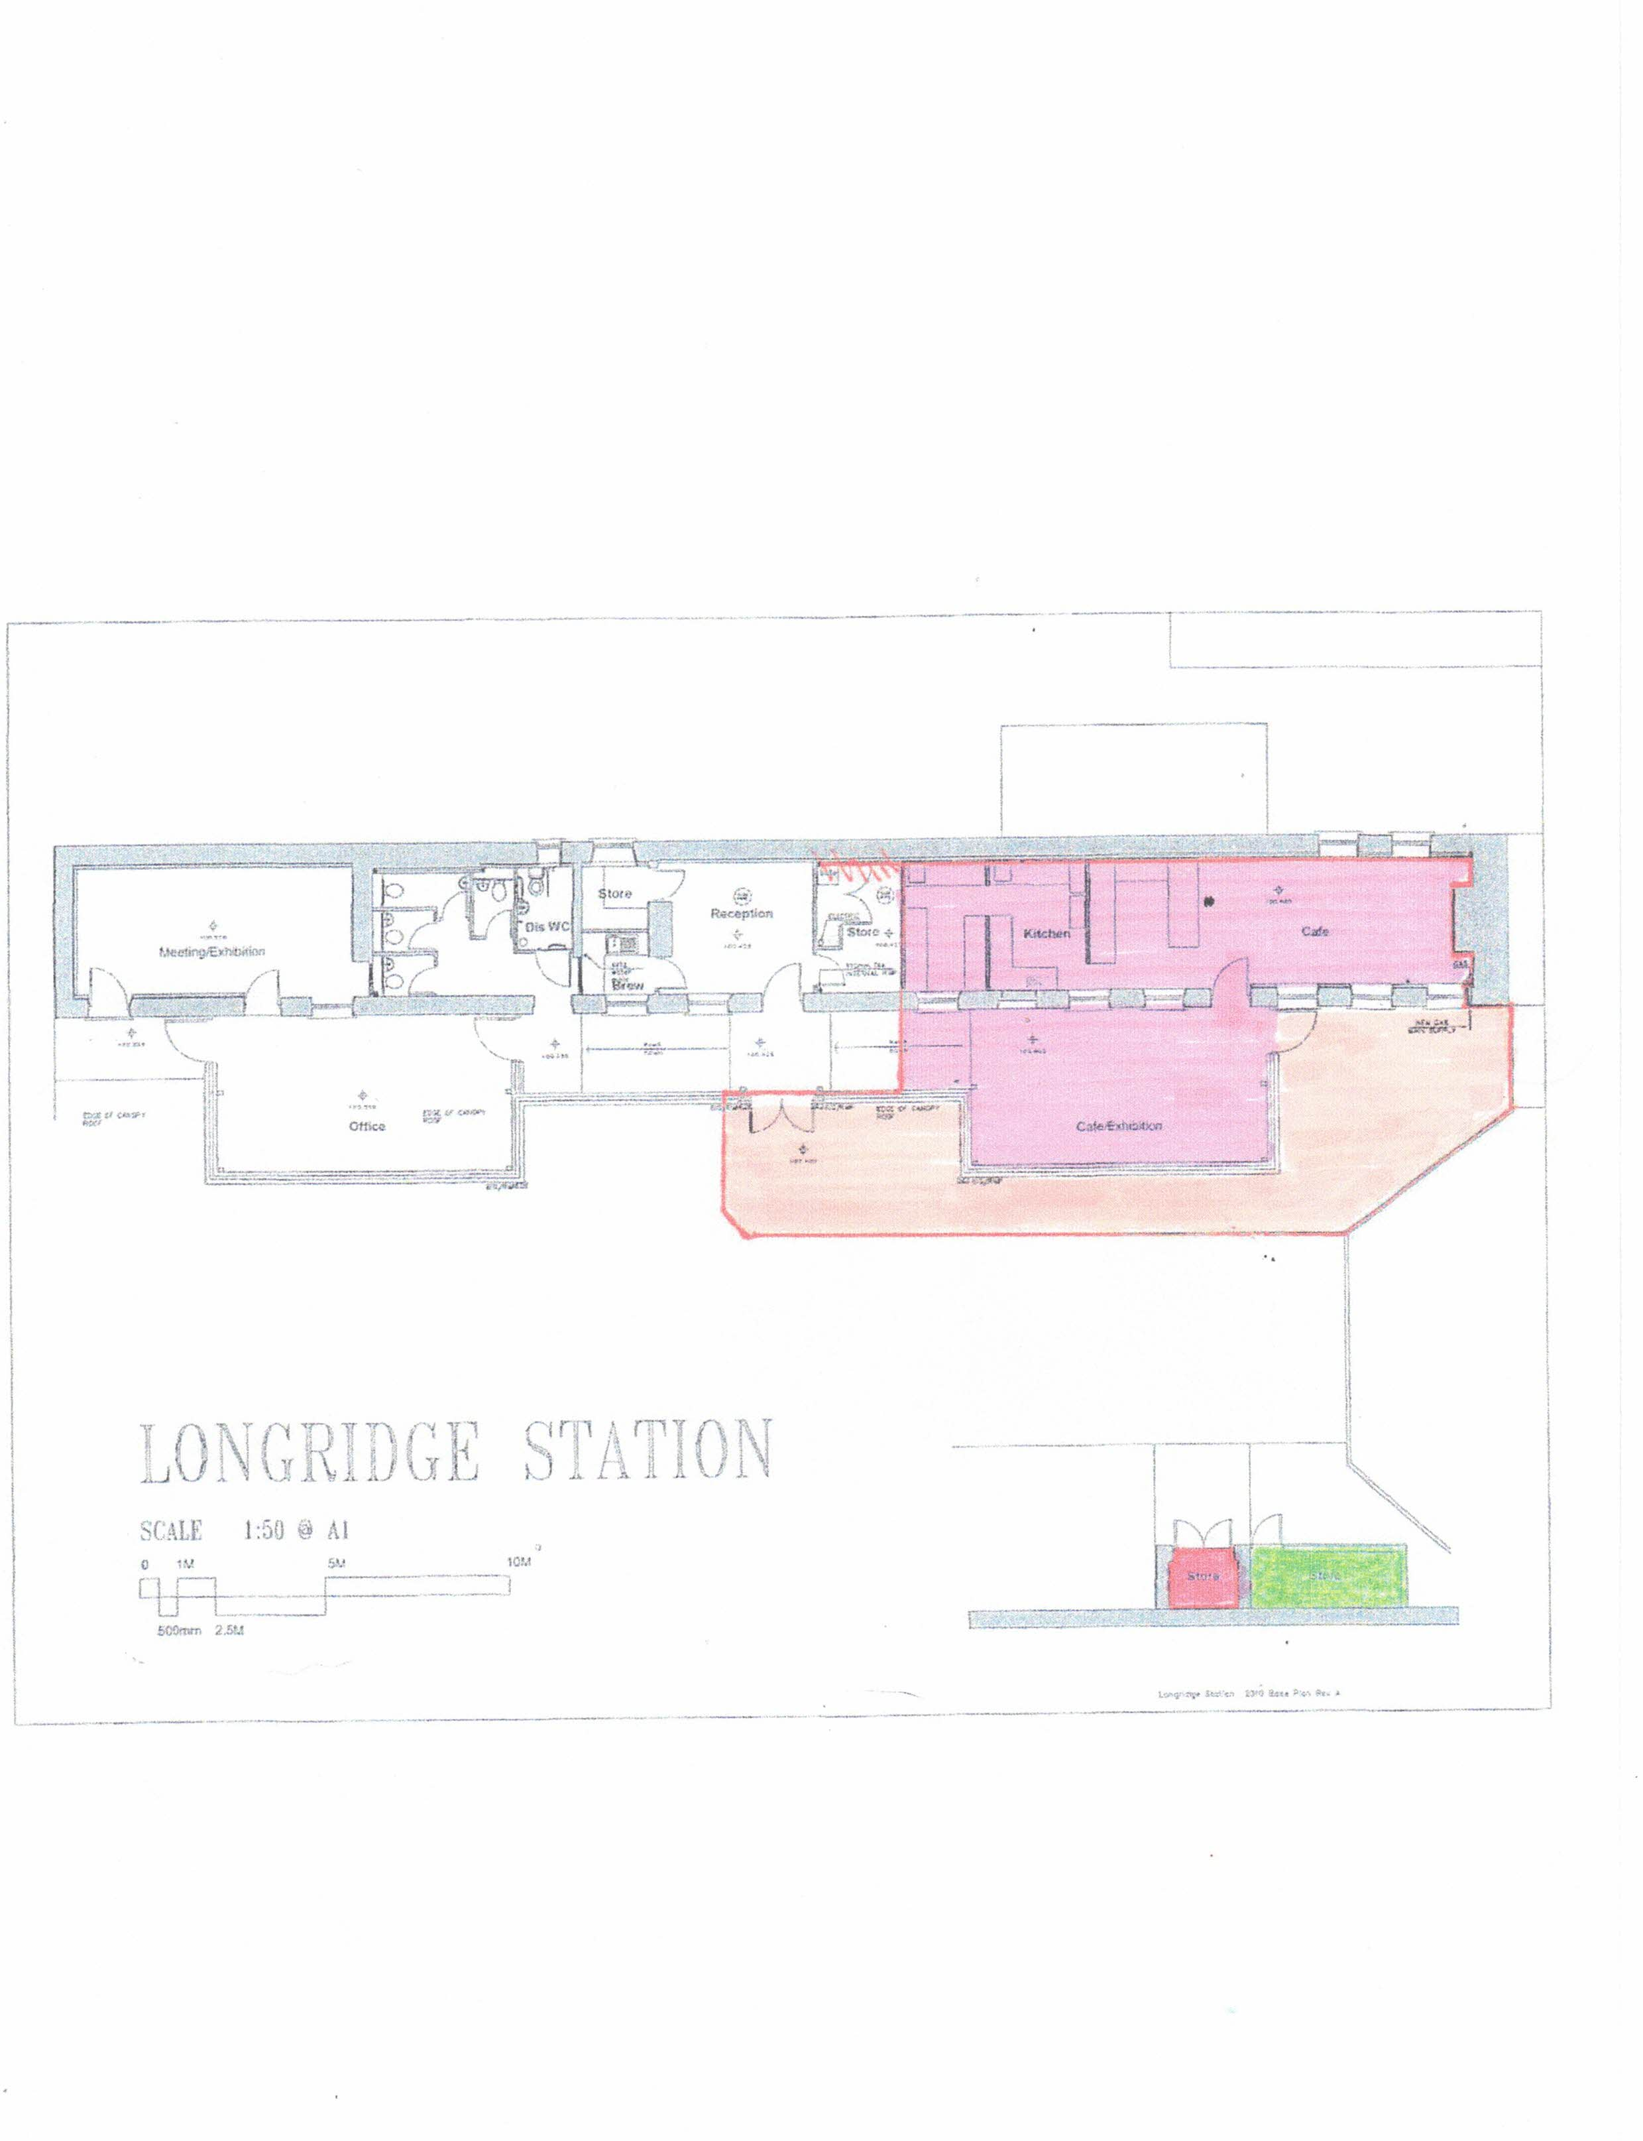

Fire Beacon

Fire Alarm

Fire Alarm

Fire Alarm

Fire Alarm

Fire Alarm

Manual Call Point

Manual Call Point

Manual Call Point

Manual Call Point

Fire Alarm

Fire Escape

Fire Escape

Fire Escape

Fire Escape

**[Appendix B]**

**Station Buildings**



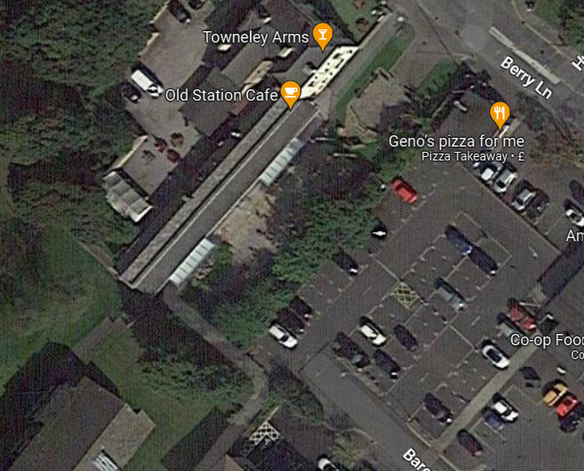

Fire Safety Evacuation Point- Barclay Road Carpark

**[Appendix C]**



Fire Safety – Refuge Point